**Assignment NO 3:**

**Title of Assignment:**

Implement Greedy search algorithm for Selection Sort.

## Prerequisite:

Basic knowledge of Greedy algorithm and Sorting concept.

## Objective:

In this experiment, we will be able to do the following:

* + Study how selection sort works under greedy search algorithm.

1. **Outcome:** Successfully able to sort , unsorted list of numbers.

## Software and Hardware Requirement:

Open Source C++ Programming tool like G++/GCC, python,java and Ubuntu.

## Relevant Theory / Literature Survey:

In Selection Sort, we take the simplest, most intuitive approach to sort an array. Choose the smallest number, place it in the first position. Then choose the next smallest number out of the remaining elements, and place it in the second position and so on till the end.

# Intuition Behind the Algorithm

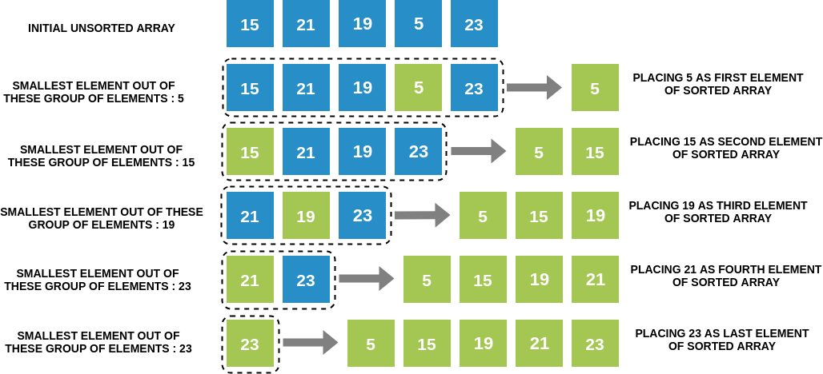

# Selection Sort Algorithm

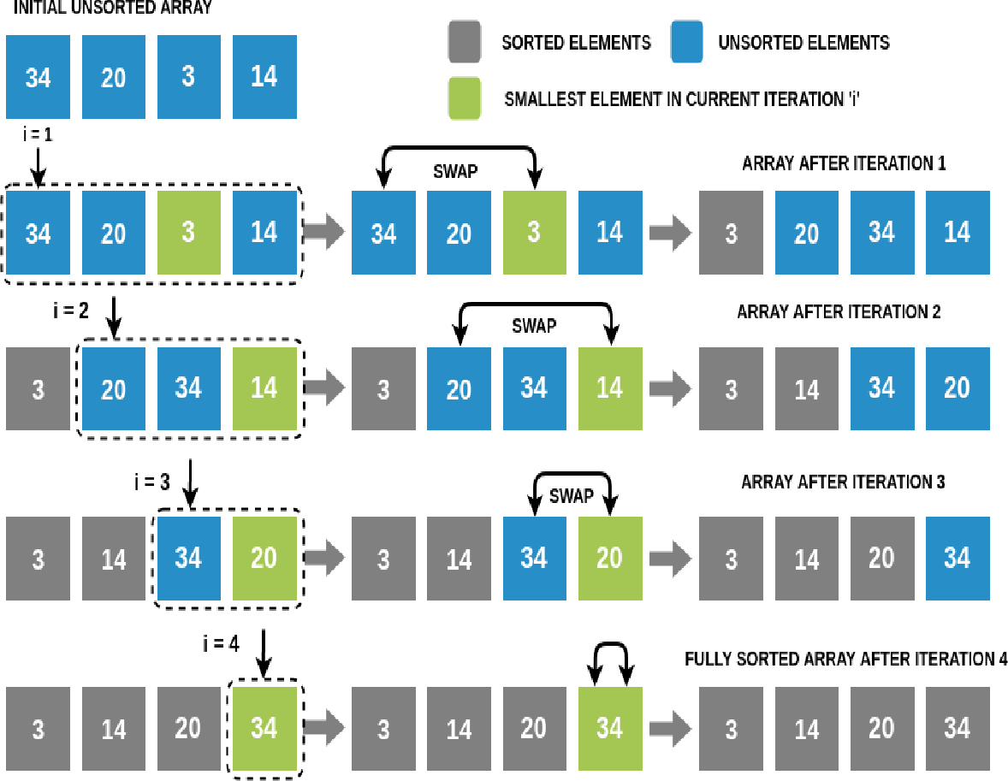

We will perform N-1 iterations on the array (N is the number of elements in the array). In iteration i (1≤i≤N-1):

* + We will traverse the array from the ith index to the end and find the smallest number among these elements. Note that if there are two smallest elements of the same value, we choose the one with the lower index.
  + We will swap this smallest element with the ith element.
  + Hence at the end of the ith iteration, we have found the ith smallest number, and placed it at the ith position in the array.

In the (N-1)th iteration, we will place the (N-1)th smallest element, which is the 2nd largest element in the array, at the second last position. This will leave us with one element which would already be at its correct place.This completes our sorting! Selection Sort Algorithm

**Program:**

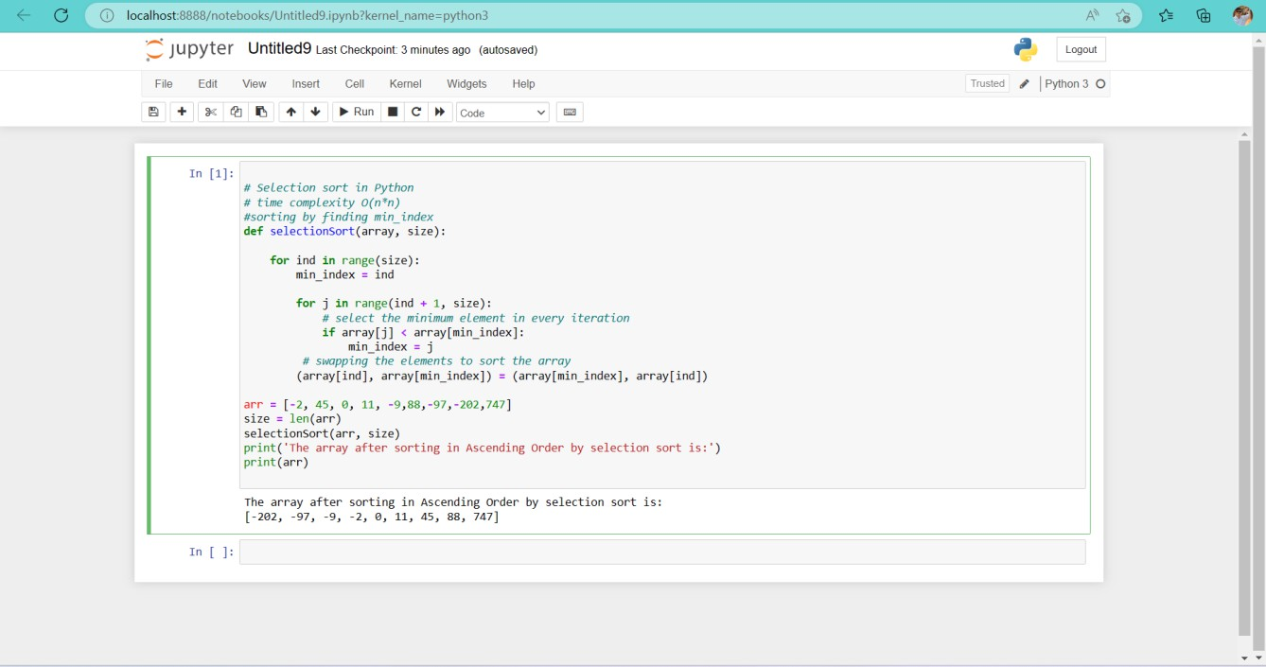

## Conclusion:

## Conclusion:

In This way we have studied how to sort , unsorted list of numbers using selection sort.